**Deploy Voting app on K8 using Deployment’s**

So far, we deployed applications as pods. But deploying them as pods had its own challenges. This will not help us scale our application easily if we wanted to add instances of particular service. If you wanted to update the application like an image used in the application, we have to take down the application while the new pod is created. We will have a downtime.   
Lets improve our setup using deployments. We choose deployments over replica sets as deployments automatically cretaes replica sets and it can help us perform rolling updates, roll backs and maintain record of revision and record the cause of change.

We have added more pods for the front end applications by cretaing deployment and set replicas to 3. First, we will start with one replicas for each of these components and later we will see how easy it is to scale them to 3 or more. We will also encapsulate the databases and woker applications with in deployments. First, create a folder for this project and create voting-app-deploy.yaml file.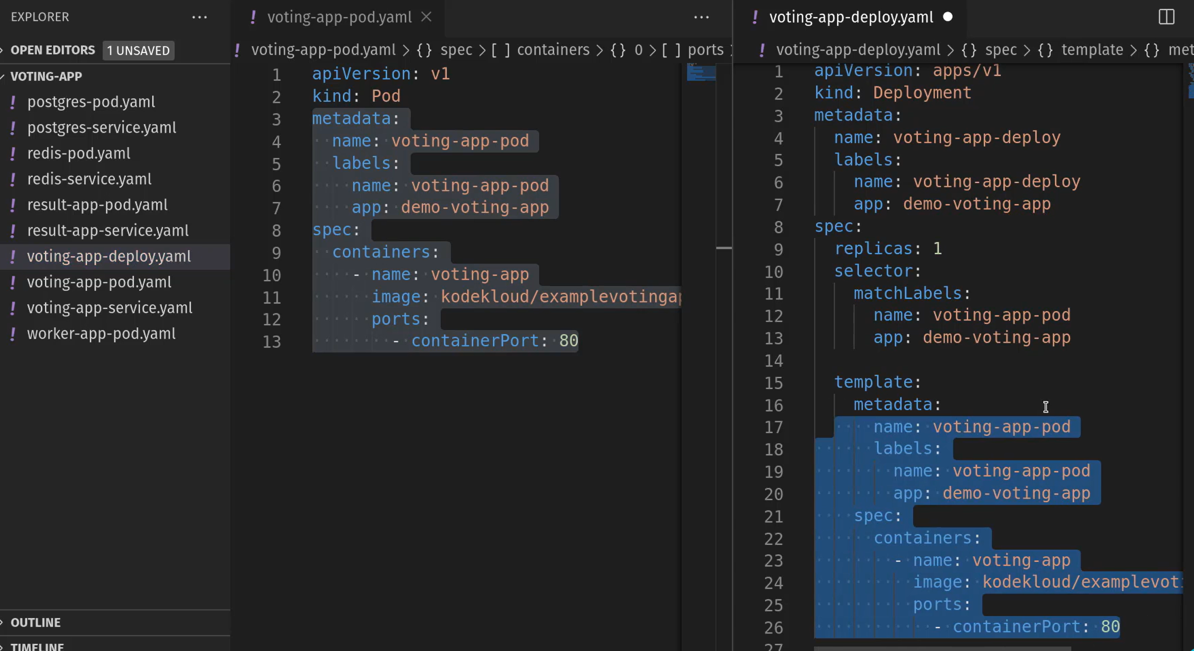The matchLabels in selector section should have same lables given for pod template. And in template we need to have pod definition template. So, copy everything in metadata and spec sections of the voting-app pod definition yaml file. After this, complete redis-deploy.yaml file with same concept. 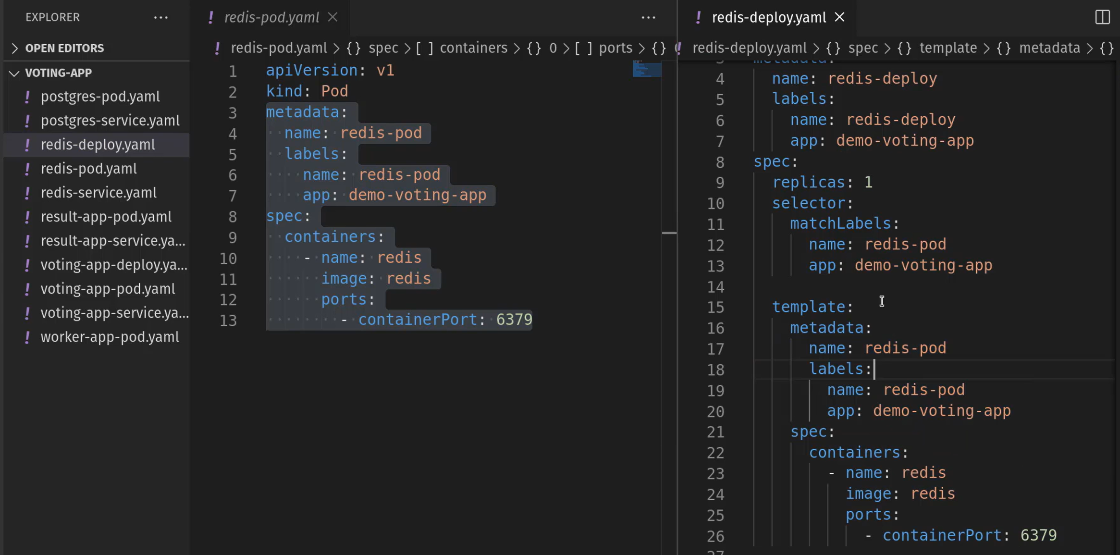Now, writing deployment file for postgres SQL service.

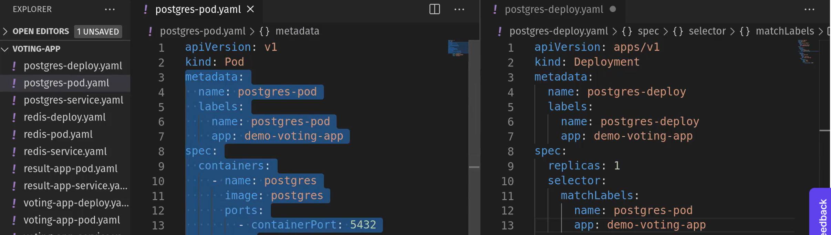 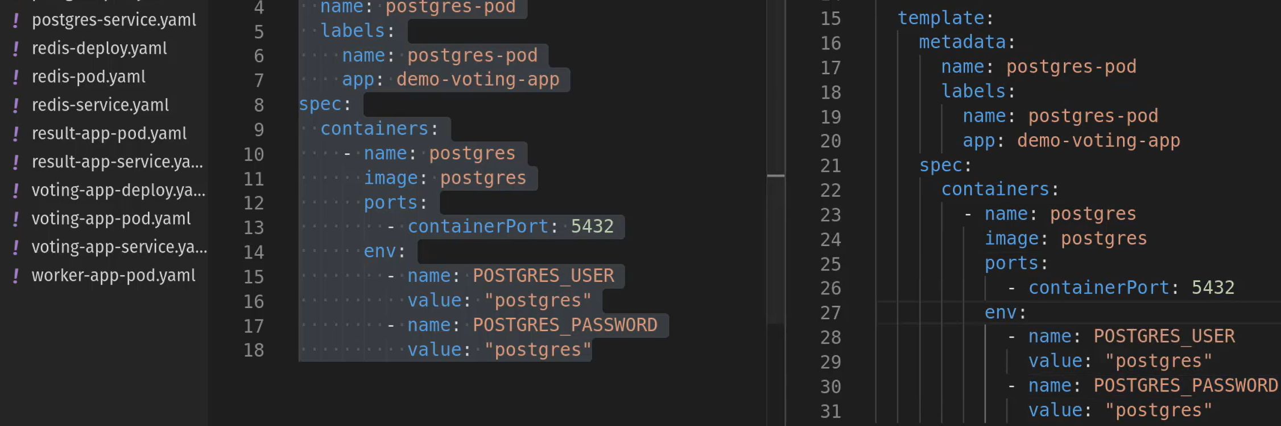Woker app deployment file: 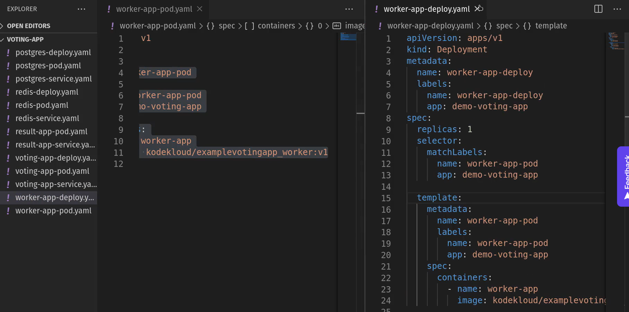result app deployment file: 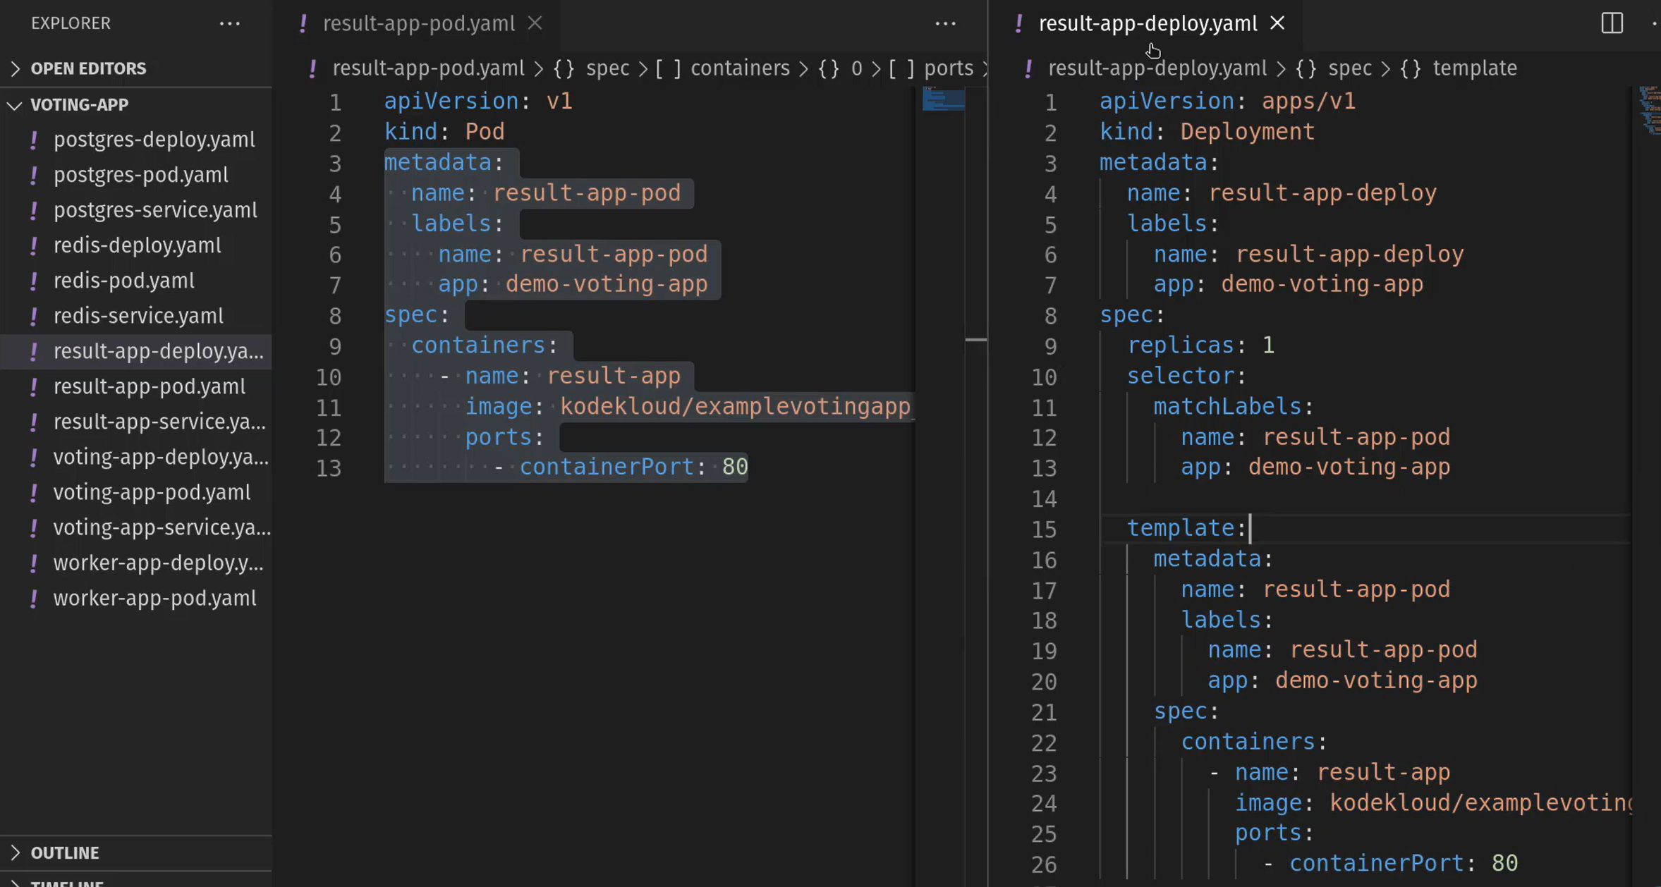

Now we are done with all the deployment yaml files. Also, copy all the service files created in previous project for the same voting app to this project folder. Before we create deployments lets make sure there aren’t any pods running in the cluster. 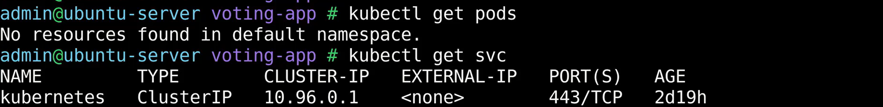There are no pods and services other than the kuberenetes default one. Let’s first create voting app deployment and voting app service.   Similarly, create the redis and postgres deployments and services. 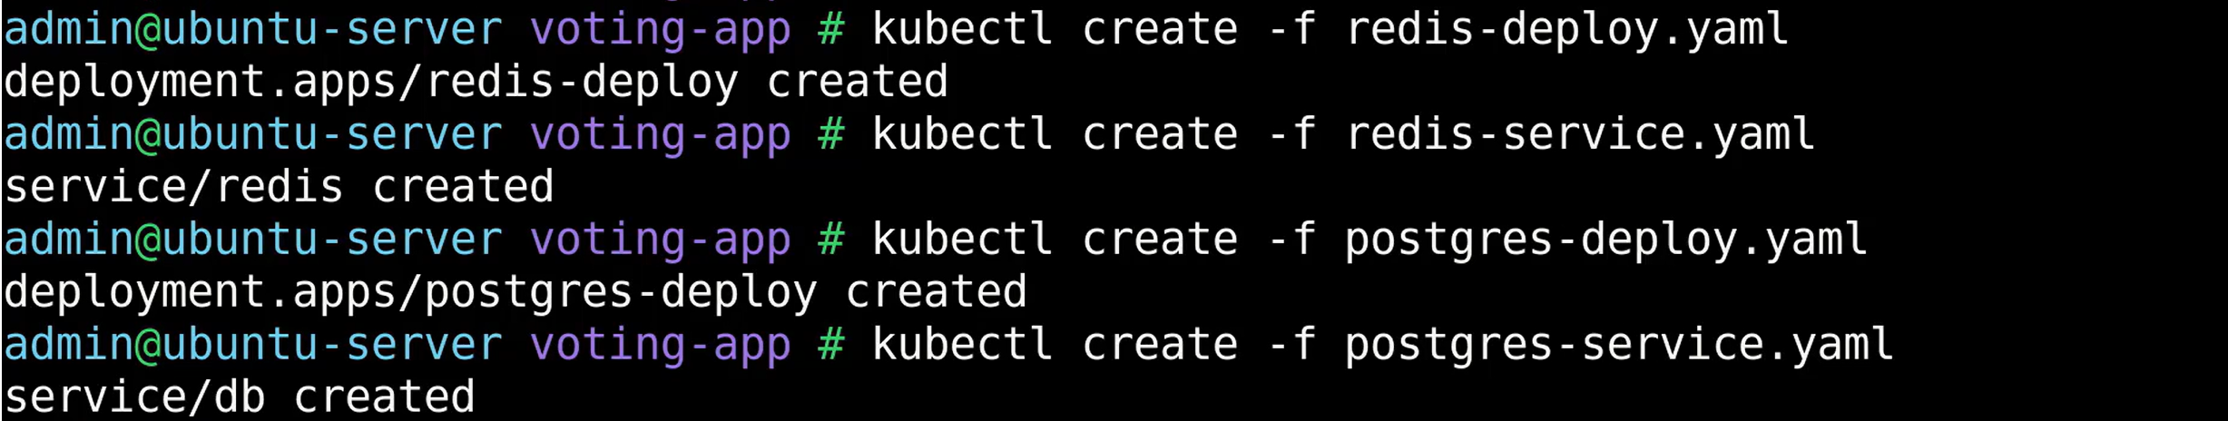Make sure everything is created – deployments, pods and services.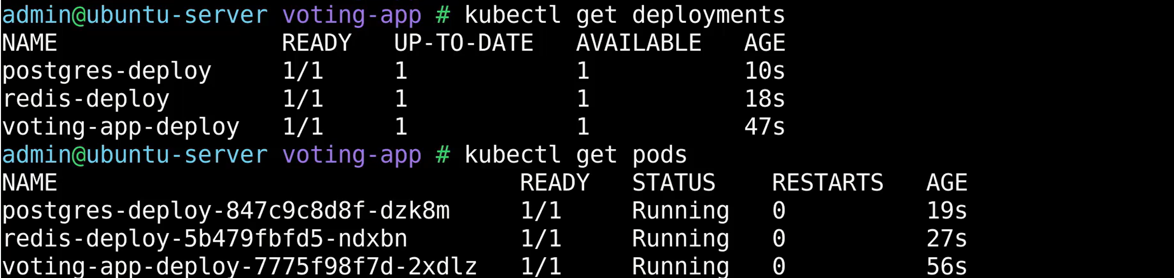 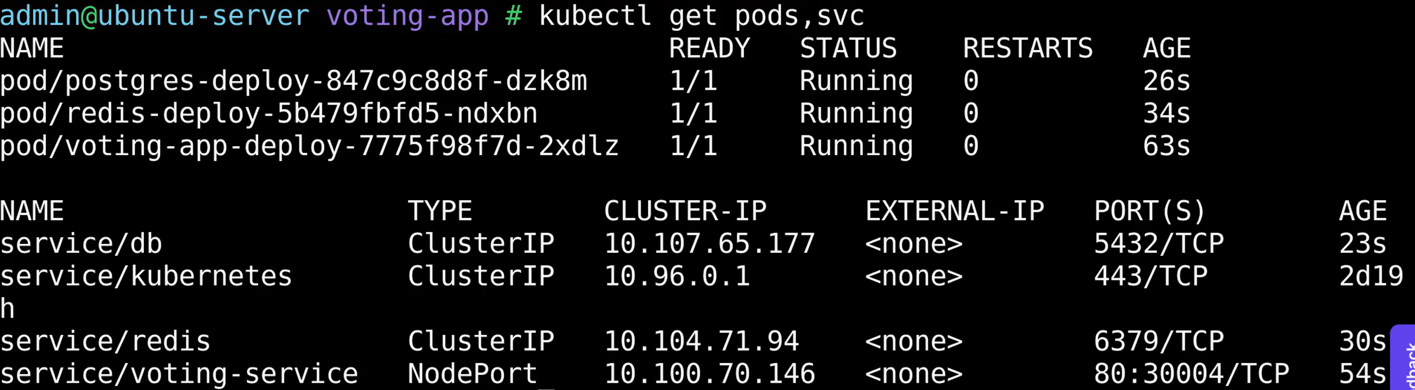   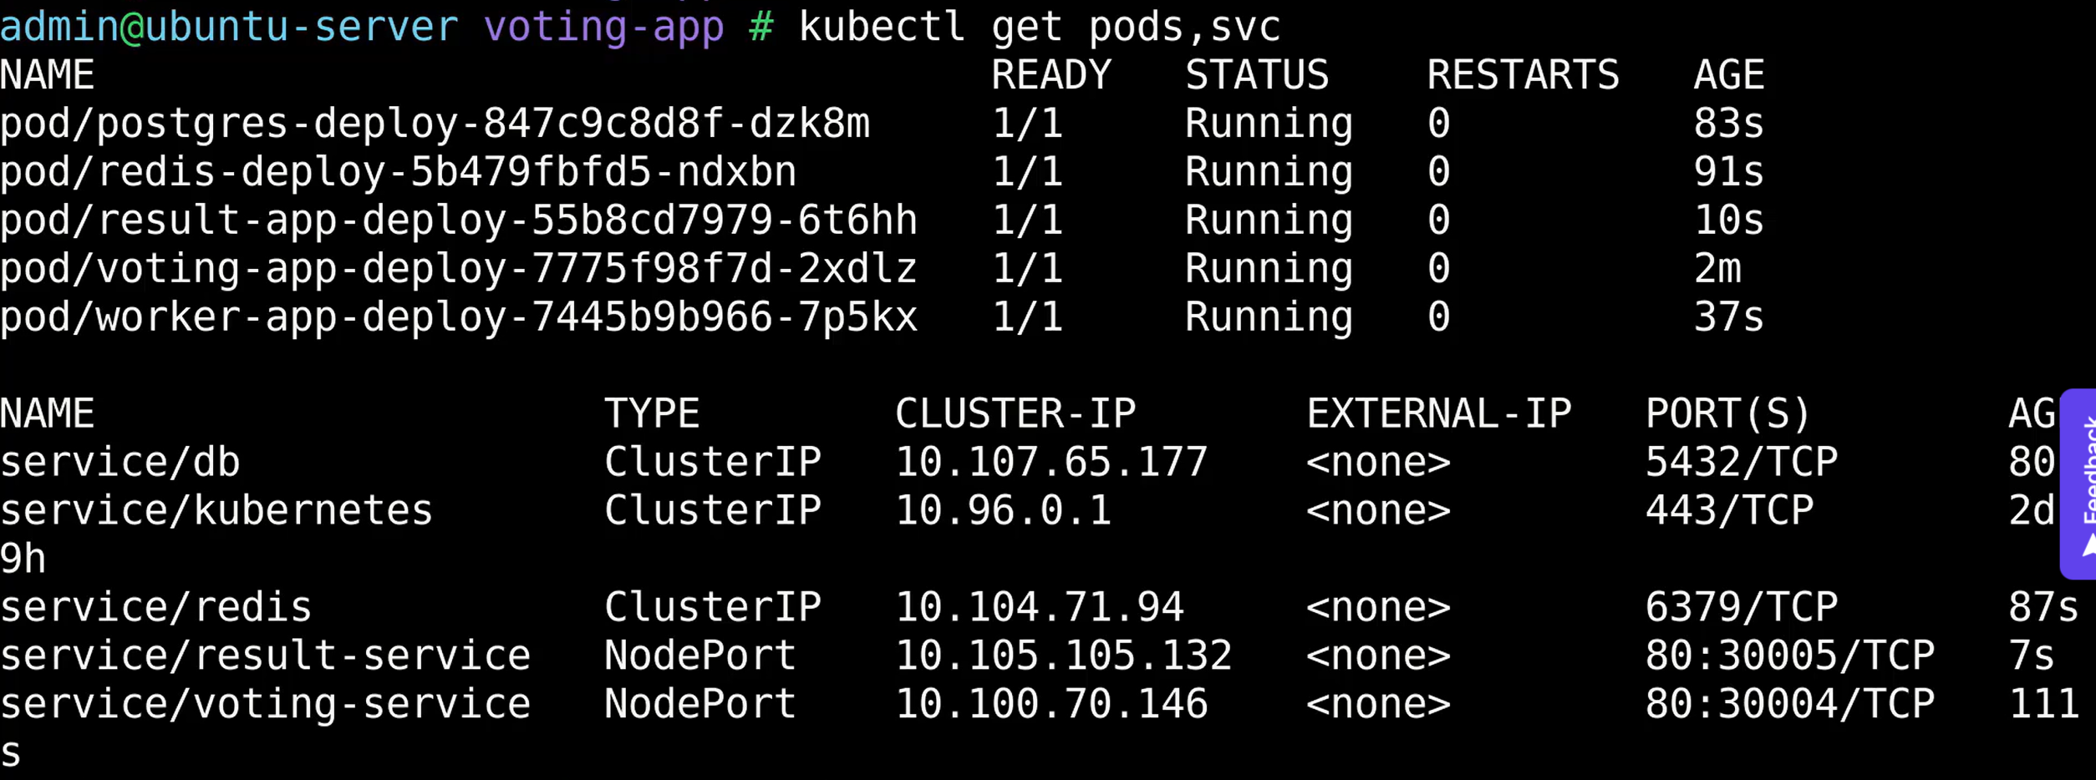We can now see everything is working as expected one out of one pods are up and running.

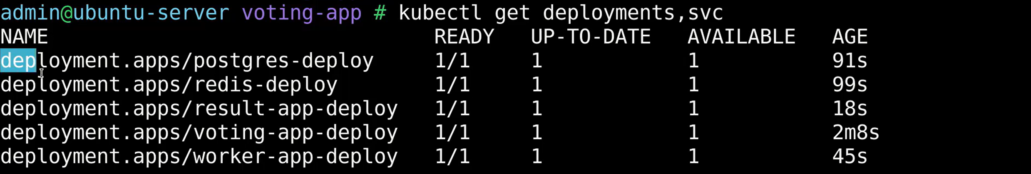Five deployments are also in running state. Let’s check the URL’s: Try to access the web servers in the browser. 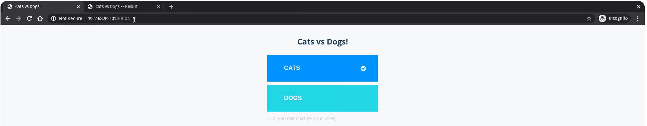 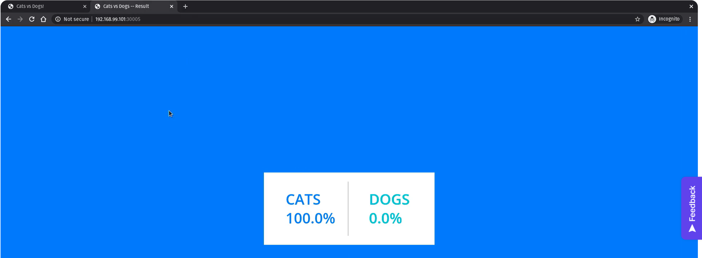**Scale up the deployments:**

Run the Kubectl scale command to scale up the voting app replicas to 3. So, it will create three pods of each.   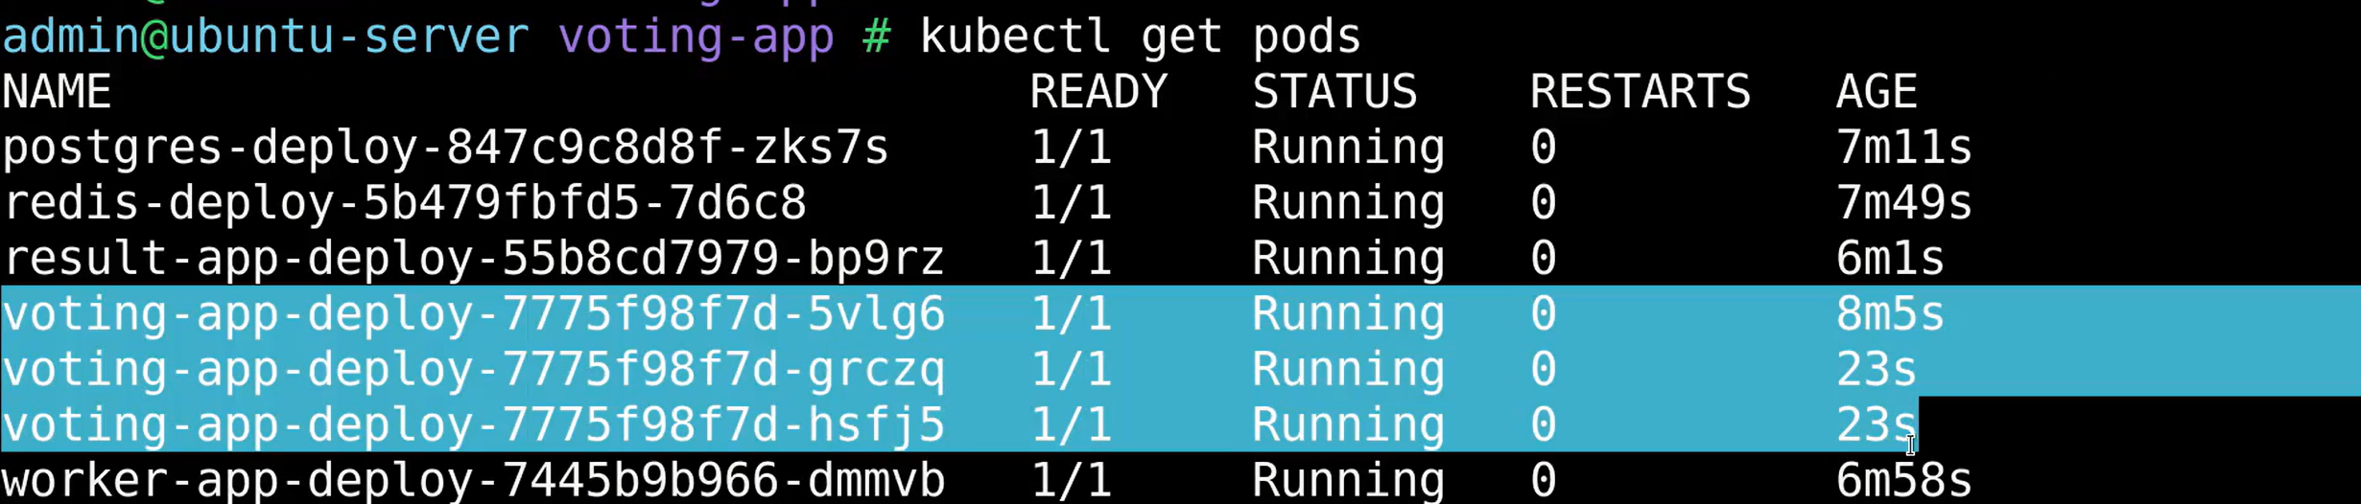Go and try to change the vote multiple times and see each time it will processed by new pod. We can see that at the bottom of the voting web page.   How easy it is to scale our applications with deployments.

**GitHub repos:**

KodeKloud repo for this project: <https://github.com/kodekloudhub/example-voting-app/tree/master/k8s-specifications> this is cloned form below repo.

Repo for Voting-app: <https://github.com/dockersamples/example-voting-app>